[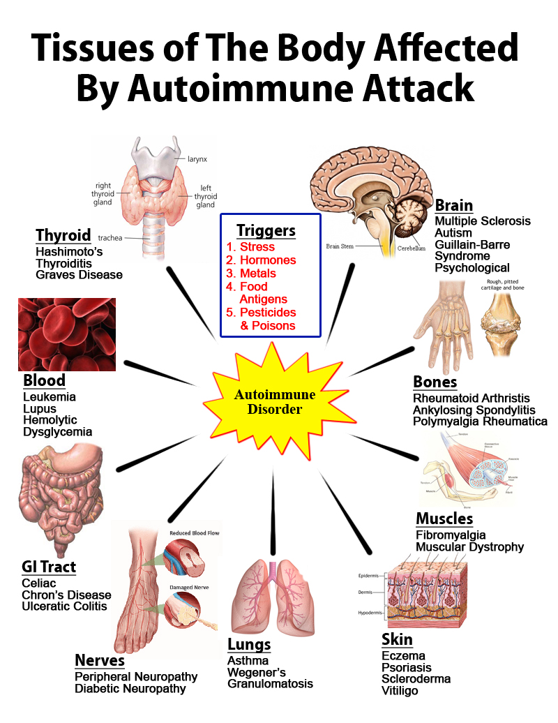](http://www.helpmychronicpain.com/blog/bid/114031/Autoimmune-Diseases-On-The-Rise-How-To-Minimize-Your-Risk)