Reducing High Cholesterol, Triglycerides & Lp(a) levels

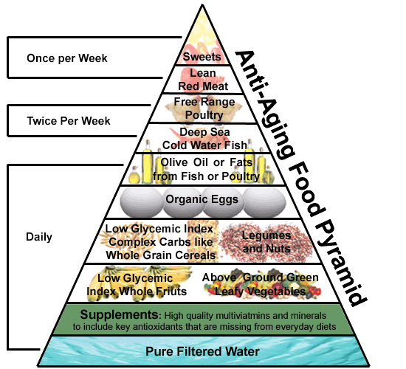
Diet Tips for Lowering Cholesterol
- Reduce overall fat, especially trans-fat commonly found in fried foods and margarine. Use oil or food that are high in Omega-3 fatty acid, such as olive, rapeseed oil, flaxseed and flaxseed oil. Omega-3 fatty acid increase serum HDL Cholesterol. Avoid polyunsaturated and saturated oil, as they increase the cholesterol and triglycerides levels. Stay with mono-unsaturated fat such as olive oil for all cooking needs.
- Eliminate refined carbohydrates and sugar from your diet and substitute complex carbohydrates that have lots of fiber. Fruit should be the major source of sweetness in your diet. Fruits are filled with pectin and fiber, which work wonders in lower serum cholesterol.
- Oat bran, oatmeal, and dry beans out of a can are foods that have been shown to lower LDL cholesterol. Oat bran has been shown to reduce LDL cholesterol by up to 20% and to increase HDL cholesterol by up to 20%. Grapefruit - segments and membranes, not the juice - drives down cholesterol. Also fresh oranges, apples, garlic, onions, barley, ginger, and shitake mushrooms.
- If tolerated eat lots of raw onion - at least half a medium onion a day. This has been shown to raise the good HDL cholesterol by up to 30%.

Supplements for Lowering Cholesterol and Triglycerides
Common Name | Common Use For/MOA | Dose
Beta Sitosterol | - Found in soybeans, wheat germ and corn oil helps stop the absorption of cholesterol | Follow directions on bottle
Copper | - Lowers LDL, clotting disorders, heart function | 1 mg/day
Chromium | - Lowers LDL, and triglycerides, and raises HDL | 500-1000 mcg/day
Fish oil/krill oil omega 3 | - Lowers LDL | 1-4 grams/day
Flaxseed |  | ¼ cup freshly ground seed QD
Niacin | - The form that improves cholesterol levels is called nicotinic acid.  Three categories based on the rate of release of the niacin:  - Immediate-release niacin is effective and least expensive, but causes more flushing. It has to be taken two or three times a day.  - Sustained-release/extended-release niacin causes less flushing. However, some over-the-counter formulations may be less effective and increase the risk of liver toxicity. The extended-release form sold by prescription (Niaspan is the best-known brand) is effective, least likely to cause intense flushing and safer for the liver—but it costs even more than brand-name statins. An over-the-counter sustained-release preparation called Slo-Niacin is similar to Niaspan but much less expensive.  - No-flush niacin (inositol hexanicotinate) has no “free” nicotinic acid, so it has little or no effect on cholesterol. Still, some labels say “supports normal cholesterol.” | 1–3 grams/day  There are basically 3 different types of niacin.  - Niacin (also called nicotinic acid) the right one to get  - *Niacinamide (also called nicotinamide)  - *Hexaniacinate  Niacin (Nicotinic acid) Lowers LDL, raises HDL, lowers total cholesterol, lowers triglycerides  Niacinamide and Inositol hexanicotinate, have little or no effect on cholesterol
Plant sterols |  | 1,500–2,000 mg/day
Phosphatidylcholine | - antioxidants that support healthy microcirculation at the cellular level | 900 mg/day 3 (softgels) Phoschol
Tomato Extract (10% lycopene) | - a potent, easily absorbed antioxidant that keeps LDL cholesterol from becoming oxidized | Follow directions on bottle
Policosanol | - from rice bran, this compound helps the liver to capture LDL cholesterol and increase HDL | Follow directions on bottle
Seanol | - derived from a brown seaweed called Ecklonia cava  - 40 percent lipid (fat) soluble, so it stays in your body much longer  - sea-based antioxidant  - maintain healthy LDL cholesterol levels, increases healthy levels of protective HDL cholesterol  - helps generate nitric oxide, decreases B/P  - support the endothelial lining of your blood vessels | 300 mg/day
Grape seed extract | - helps relax arteries  - it helps to prevent LDL cholesterol oxidation | 150–300 mg/day
Garlic (allicin) | - decreases triglyceride level  - supports healthy blood pressure  - increases immune power | 500 mg concentrated form/day
Green Tea | - lowers LDL and prevents blood vessel constriction
Guggulipid | - Indian herb shown to reduce LDL even better than modern drugs on several trials | Follow directions on bottle

Elevated Lipoprotein A
Lipoprotein A, commonly called Lp(a), is a major independent risk factor for cardiovascular disease, and high Lp(a) is genetically linked. The optimum laboratory level should be under 20 mg/dl and preferably under 14 mg/dl. Currently, there are no medications or drugs that can effectively lower your Lp(a).
Fortunately, Mother Nature has provided us a much better non-toxic alternative. It consist of large doses of vitamin C, L-lysine, and L-proline. Vitamin C, L-Lysine and L-proline are the basic building blocks of collagen. When these vitamins enter our bodies, they form collagen in large amounts. This is necessary, as collagen must be replenished in blood vessels to remain healthy and plaque free over periods of time. The reason is simple – Lp(a) is manufactured in the liver in response to aging vascular system and “micro-fissures” in the endothelial vascular wall. The body, in its attempt to patch up these fissures, produce cholesterol and its relative Lp(a). Unfortunately, both cholesterol and Lp(a) are sticky, making them perfect for the job. Lp(a) is many times more potent than cholesterol in its patching ability and has a tendency to attract other Lp(a) particles. The aggregation of Lp(a) forms a plaque that leads to vascular occlusion.

Supplements for Lowering Lipoprotein A

Common Name | Common Use For/MOA | Dose
vitamin E (Alpha-tocopherol) | intercept free radicals and thus prevent a chain reaction of lipid destruction | 400 IU or 800 IU
Vitamin C (ascobyl palmitate) |  | 1-5 grams/day
Niacin (Nicotinic acid) |  | 1-4 grams/day
Coenzyme Q10 (CoQ10)  (Ubiquinol is preferred active ingredient) | Enhances mitochondrial function. CoQ10 supports healthy HDL and prevents the excess oxidation of LDL | 100-300 mg/day
L-carnitine | works synergistically with CoQ10 to support healthy cholesterol and improves transportation of nutrients from the extra-cellular space to the intra-cellular space | 500-1000 mg/day
Digestive Enzymes | Including lipase and amylase help breakdown food and aid in digestion. Bowel transit time is also reduced, resulting in less stasis and absorption of fat. | Follow directions on bottle
Probiotics | "Friendly bacteria" such as L. Acidophilus help promote healthy cholesterol by converting it into a less absorbable form and sending it down the gastro-intestinal tract for emptying. It also increase enzyme production such as proteases that digest proteins and lipases that digest fats. | Dosage: 1- 2 capsules a day, between meals.  Look for products that include (DDS-1) L. Bacillus Acidophilus
Pantethine and pantothenic acid, | The use of pantethine to reduce total cholesterol, LDL cholesterol, and triglyceride level, while raising the good HDL cholesterol at the same time | 400 to 900 mg each per day
Milk Thistle (Silybum marianum | Is a group of flavonoid compounds. Silymarin prevents damage to the liver by acting as an antioxidant. It is much more effective than vitamin E and vitamin C. Liver is the major detoxification center of the body  Silymarin also works by preventing the depletion of glutathione. The higher the glutathione content, the greater the liver's capacity to detoxify harmful chemicals. | 70 to 200 mg/day
Herb Tea | Enhanced intestinal motility  Senna leaf, peppermint leaf, stevia leaf, buckthorn bark, damiana leaf, RED peel, chamomile flower, and uva ursi leaf. | To fortify your regular meals with digestive enzymes (to enhance the breakdown of food in the gastro intestinal tract). After your evening meal, you can begin drinking tea. Start slowly. You should begin by steeping the tea 2 minutes (in 1-2 cups of water) for the first 3-5 days. As your system adjusts, you may increase steeping to 5 minutes. Most individuals will experience increased bowel movements, or slight cramping, during the first few days. This is due to the initial cleansing of the body system and is normal.
*Highlighted supplements are my first place I usually start with

