Reversing Insulin Resistance & Pre-Diabetic/Type II Diabetes

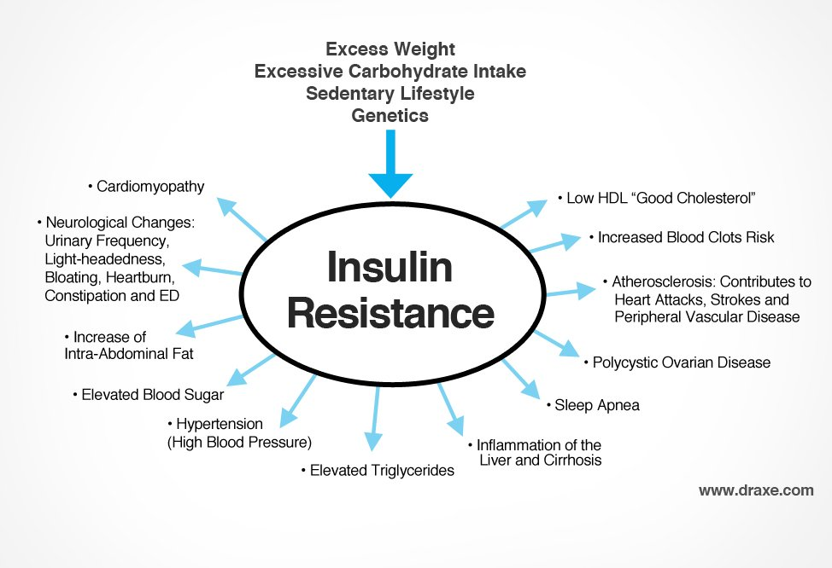
Foods You Must Remove/Reduce to Reverse Diabetes Naturally
Refined sugar
Grains
Conventional cow’s milk (A1 cow’s milk)
Alcohol
Top Foods to Cure Diabetes
High fiber foods help slow down glucose absorption. Aim for at least 30g of fiber per day from vegetables, avocados, berries, nuts, and seeds. Fiber Powder (10 g) Fiber from vegetables and seeds can control blood glucose. I recommend finding a supplement that contains sprouted chia and flaxseeds.
Foods high in chromium Broccoli, raw cheese, green beans and grass-fed beef are all high in chromium, however broccoli has the highest amounts by far.
Foods with a low glycemic load Low glycemic foods include vegetables, nuts, seeds, avocados, coconut, organic meat, eggs, wild caught fish and raw pastured dairy

Supplements for Balancing Blood Sugar
Common Name | Common Use For/MOA | Dose
Cinnamon | - potent antioxidant  - improves insulin sensitivity by activating insulin receptors  - reduces Cholesterol & Triglycerides | ¼ to ½ teaspoon water-soluble cinnamon extract (or the supplement equivalent) twice a day or 2 tsp daily
Vitamin E | - potent antioxidant  - It improves glucose control and protects blood vessels and nerves from free radical damage | 400-800 IU/day (take only natural form d-alpha-tocopherol or d-alpha-tocopherylural)
B-6 & B-12 | - support nerve health, reduce neuropathy | B-6 50-100 mg QD  B-12 150-1000 mcg QD
B7 Biotin | - manufactures and utilization of protein, fats, and carbohydrates | Biotin 300mcg/day
B1 (benfotiamine) | - prevents the formation “advanced glycation end products” (AGE’s) and helps reverse (AGE) related damage  - improves nerve function, circulation | 300 mg/day
Vitamin C (ascorbate) | - lowers levels of sorbitol reduces damage to cells in the eyes, kidneys, and nerves | 1000-5000 mg/day
Vitamin D3 | - boost production of antimicrobial peptides called cathelicidins, which destroy viruses, bacteria, and other germs  - important role in helping your body process glucose | 5000 IU/day
Magnesium | - energy production and protein synthesis, cellular replication, and DNA production  - decreases insulin resistance | 500-1000 mg/day (threonate, glycinate & malate)
Vanadium | - mimics insulin in the body and helps maintain normal blood sugar levels  - essential in formation of bone and teeth | 100 mg/day (vanadyl sulphate)
Chromium | - improves the action of insulin and helps move glucose and other nutrients into the cells | 500-1000 mcg (chromium picolinate)/day
Berberine (plant alkaloid) | - stimulates the uptake of glucose into the cells, improves insulin sensitivity, and reduces glucose production in the liver | 1500 mg/day
Gymnema sylvestre (extract from the leaves of a climbing plant) | - slows the transport of glucose from the intestines to the bloodstream | 200-400 mg/day
Banaba leaf extract | - contains colosolic acid which promotes glucose transport into cells | 3 mg/day
Resveratrol | - its positive effects on the sirtuin family of enzymes  - facilitate DNA repair  - protects against oxidative stress  - reduce inflammation  - increase insulin sensitivity | 100–250 mg/day (standardized extract of trans-resveratrol)
Alpha-lipoic acid (ALA) | - one of the most powerful antioxidants out there for fending off the harmful free radicals that can attack your blood vessels  - Improves insulin sensitivity and reduces symptoms of neuropathy | 600-1200 mg/day
Oliginol | - form of lychee fruit that improves microcirculation, stimulating blood flow to extremities | 50 mg/day
Exercising Balances Your Blood Sugar | Exercising Balances Your Blood Sugar | Exercising Balances Your Blood Sugar
Highlighted supplements are my first ones I start out with!!

