Thyroid disease: Hashimotos
The causes of thyroid issues can be varied, but common causes are:
- Toxicity: Radiation and Heavy Metal exposure
- Deficiency: In Iodine and Selenium
- Food Intolerance: Gluten and A1 Casein Allergy
- Hormone Imbalance – High Cortisol from stress, too many carbs, too little fat in diet
- Increasing Stress
  - Emotional stress activates pathways involving the inflammatory immune messengers IL-6 and TH-17. This activity creates an autoimmune flare-up. Unhealthy relationships with your spouse, co-workers, or friends can promote autoimmune flare-ups, as can a bad work environment, or other significant and chronic lifestyle stressors. If you have Hashimoto’s you need to create a healthy emotional environment for yourself. Bad personal relationships or poor work environments can be detrimental to Hashimoto’s patients

Not being Strictly Gluten-Free

You are either 100 percent gluten-free or you’re not gluten-free. Choosing to eat gluten-free only when it is convenient is not a gluten-free diet. If you are not strict about your food being 100 percent gluten-free when you eat out and you continue to consume condiments that have gluten, regular beer, and foods fried in fryers that use the same oil for breaded foods, then you are still being exposed to gluten. Gluten is a major trigger for most Hashimoto’s patients and many cannot improve until they are 100 percent gluten-free

Not avoiding gluten cross-reactive foods

Although a strict gluten-free diet is a great place to start, if you are still eating foods that cross-react with gluten you may not recover well. Cross-reactive foods have proteins similar in structure to gluten and can trigger the same immune response as if you were eating gluten. The most commonly ignored cross-reactive food is milk (casein), followed by rice, corn, sesame, and gluten-free oats. In fact, it is best to avoid all grains and adopt a diet such as a Ketogenic/Paleo/Primal diet when you have Hashimoto’s.

Ignoring their brain health

The most common form of collateral damage in chronic Hashimoto’s patients is accelerated brain degeneration. Brain degeneration leads to identical symptoms of hypothyroidism, including fatigue and depression.

Ignoring insulin sugar spikes

Surges of insulin that follow eating or drinking something sugary or starchy (sweet coffee drinks, desserts, bowls of pasta or rice, bread, etc.) trigger the inflammatory TH-17 activity, which promotes autoimmune flare-ups. Eating sweets throughout the day or overeating promotes insulin surges, which can be identified by symptoms of fatigue or sugar cravings immediately after eating. If you have those symptoms after eating it means you are not managing your insulin levels and your Hashimoto’s autoimmune response will be hard to tame.

Missing meals

When blood sugar gets too low it raises the inflammatory messenger IL-6 and promotes autoimmune flare-ups. Symptoms of low blood sugar are most noticeable between meals or if you skip meals and include shakiness, blurred vision, crankiness and irritability, and loss of function. If you feel a jump in your function and energy after eating it confirms your blood sugar was low—when your blood sugar is stable the only thing you should feel after eating is not hungry

Passive attitude

The passive patient does not question or challenge her doctor. If you are a passive Hashimoto’s patient and you do not take your health into your own hands you may not fare as well as the person who educates herself. The conventional model is based only on lowering your TSH with whatever thyroid medication your insurance plan or doctor prefers. Once TSH is within lab ranges, this model has nothing more to offer except to check your TSH once a year. It takes time and effort, but the thyroid patient who wants to feel better needs to roll up her sleeves and master the various mechanisms of Hashimoto’s. The more you understand Hashimoto’s the more likely you are to successfully manage your health.
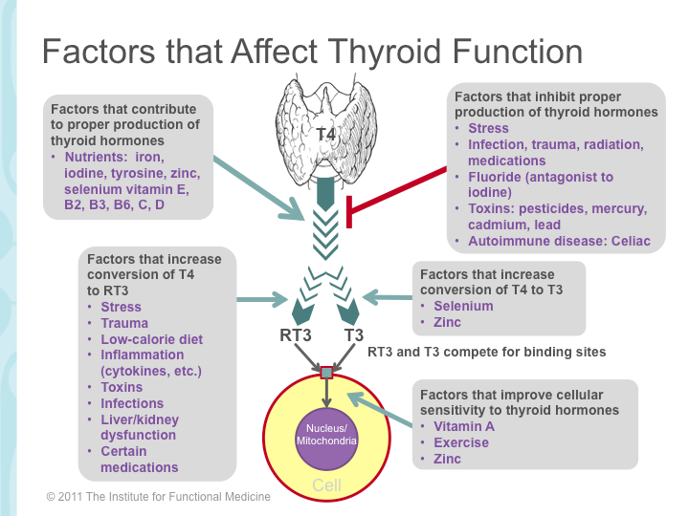

To Reverse Pathology, You Need a Whole Mind-Body Approach

Thyroid health is so much more than pumping out a hormones – it is a sophisticated conversation between the brain, gland, hormones, and the receiving cells and tissues.
This circuitry is dependent on another hormone, cortisol, produced by your adrenal glands, signaled by your brain.
This is why hypothyroidism can also look like anxiety, palpitations, insomnia, and sweating, and why one person may feel restored on thyroid hormone and another decimated.
One has to evaluate the state of adrenal function, we have to dig a step deeper and ask what is taxing the adrenals. From this point of inquiry, we are typically talking about gut, diet, and environmental immune provocation.
This is the model of integrative medicine that establishes root-causes, considerations like gluten enteropathy, sugar imbalance, fluoride toxicity, and iodine deficiency as potential drivers of thyroid hypofunction. The many lifestyle and environmental factors that can influence this relationship are prime examples of the web-like, whole mind-body approach that we must take in an effort to truly reverse pathology.
When trying to correct thyroid function, you can’t ignore the adrenals. Adrenals are glands that sit over your kidneys and make a variety of hormones that help you respond to every day demands including cortisol, DHEA, pregnenolone, aldosterone, norepinephrine, and epinephrine. There are stages of response to stress, acute and then chronic, that describe exaggerated and then diminishing returns on adrenal hormone functioning.
Stress management, low sugar diet, and sometimes, B5, B6, and vitamin C, Adaptogenic herbs like Rhodiola can also be helpful in balancing the body’s response to stress. Thereby helping out your thyroid.

Helping the body correct itself with supplements and prescription hormones. Supporting the immune system’s correction and thyroid hormone production is truly an exercise integrative medicine.

Natural Hypothyroidism Treatment
Here are the 9 suggestions to fixing your thyroid issues:
1. Go Gluten and A1 Casein FREE – the most common allergies and food intolerances today are from wheat and dairy products because of the hybridized proteins of gluten and a1 casein. These proteins can cause “Leaky Gut” which in turn will cause inflammation of the thyroid and effect its function. Follow a grain-free diet or at least go gluten free. Then only consume dairy products that come from A2 cows, goat milk, or sheep milk.
2. NO BPA – Bisphenol A (BPA) is found in plastic bottles and can disrupt your endocrine system and effect your thyroid. I recommend only drinking out of glass, stainless steel, or BPA free plastic bottles.
3. Check Your Iodine Levels – If they are low use an iodine supplement.
4. Heavy Metal Detox - I recommend using a combination of Milk Thistle, Turmeric, Chlorella, and Cilantro to detox these harmful metals from your cells and organs.
5. More Selenium – Make sure you’re getting enough selenium in your diet but also don’t go overboard. Some of the best selenium containing foods are brazil nuts, salmon, sunflower seeds, beef, mushrooms and onions. Selenium is critical to antioxidant enzymes and immune reactivity, 200 mcg/day is a typical dose.
6. Adaptogen Supplements – Can lower cortisol levels and improve thyroid function like Ashwagandha, holy basil, rhodiola, and Black Licorice root.
7. Lower Carbohydrate Intake - Lower your intake of sugars and grains and replace them with healthy fats. Most women especially consume far too many carbs which increase estrogen and negatively affect the thyroid. Instead consume healthy fats that will balance hormones, like: coconut oil, coconut milk, avocado, grass-fed beef, wild salmon, chia, flaxseeds, and hemp seeds.
8. Probiotics-Treat your Leaky gut with probiotics and digestive enzymes

9. Zinc- is essential to the conversion of T4 to T3. Zinc at 30mg with 2mg of copper is a typical dose.

